**CIA-2**

MUDDULURU JOTHISH KUMAR

727721EUIT093

TASK-1

**package** cia2;

**import** org.openqa.selenium.By;

**import** org.openqa.selenium.WebDriver;

**import** org.openqa.selenium.WebElement;

**import** org.openqa.selenium.chrome.ChromeDriver;

**import** org.openqa.selenium.chrome.ChromeOptions;

**import** org.testng.AssertJUnit;

**import** org.testng.annotations.Test;

**import** io.github.bonigarcia.wdm.WebDriverManager;

**public** **class** ques1 {

@Test

**public** **void** f()**throws** InterruptedException {

WebDriverManager.*chromedriver*().setup();

WebDriver driver;

ChromeOptions co = **new** ChromeOptions();

co.addArguments("--remote-allow-origins=*");

driver=**new** ChromeDriver(co);

driver.manage().window().maximize();

driver.get("https://www.trivago.in/");

Thread.*sleep*(2000);

String actualTitle="trivago.in - Compare hotel prices worldwide";

String extractedTitle=driver.getTitle();

AssertJUnit.*assertEquals*(actualTitle, extractedTitle);

System.***out***.println("Page title is Validated.");

Thread.*sleep*(2000);

WebElement location=driver.findElement(By.*xpath*("//*[@id=\"__next\"]/div[1]/div[1]/section/div[2]/div[3]/div/div[1]/div/form/div"));

location.click();

Thread.*sleep*(2000);

WebElement ben=driver.findElement(By.*xpath*("//*[@id=\"suggestion-list\"]/ul/li[1]/div/div"));

ben.click();

Thread.*sleep*(2000);

WebElement cin=driver.findElement(By.*xpath*("//*[@id=\"__next\"]/div[1]/div[1]/section/div[2]/div[3]/div/div[2]/div/div/div/div[2]/div/div[1]/div[2]/button[2]/time"));

cin.click();

Thread.*sleep*(2000);

// WebElement coutcol=driver.findElement(By.xpath("//*[@id=\"__next\"]/div[1]/div[1]/section/div[2]/div[3]/div/div[1]/fieldset/button[2]/span"));

// coutcol.click();

WebElement cout=driver.findElement(By.*xpath*("//*[@id=\"__next\"]/div[1]/div[1]/section/div[2]/div[3]/div/div[2]/div/div/div/div[2]/div/div[1]/div[2]/button[7]/time"));

cout.click();

Thread.*sleep*(2000);

WebElement inc=driver.findElement(By.*xpath*("//*[@id=\"__next\"]/div[1]/div[1]/section/div[2]/div[3]/div/div[2]/div/div/div[1]/div/div[1]/div[1]/div/button[2]/span/span[1]"));

inc.click();

inc.click();

inc.click();

Thread.*sleep*(2000);

WebElement pet=driver.findElement(By.*id*("checkbox-13"));

pet.click();

Thread.*sleep*(3000);

WebElement apply=driver.findElement(By.*xpath*("//*[@id=\"__next\"]/div[1]/div[1]/section/div[2]/div[3]/div/div[2]/div/div/div[2]/div/button[2]"));

apply.click();

Thread.*sleep*(3000);

**if**(driver.getTitle().equals("Bengaluru (Pet friendly) Hotels | Find & compare great deals on trivago")) {

System.***out***.println("1.Verified that the user can enter the location of stay.");

System.***out***.println("2.Verified that the user can select the check-in and check-out date.");

System.***out***.println("3.Verified that the user can enter the no of rooms based on their preference.");

}

}

}

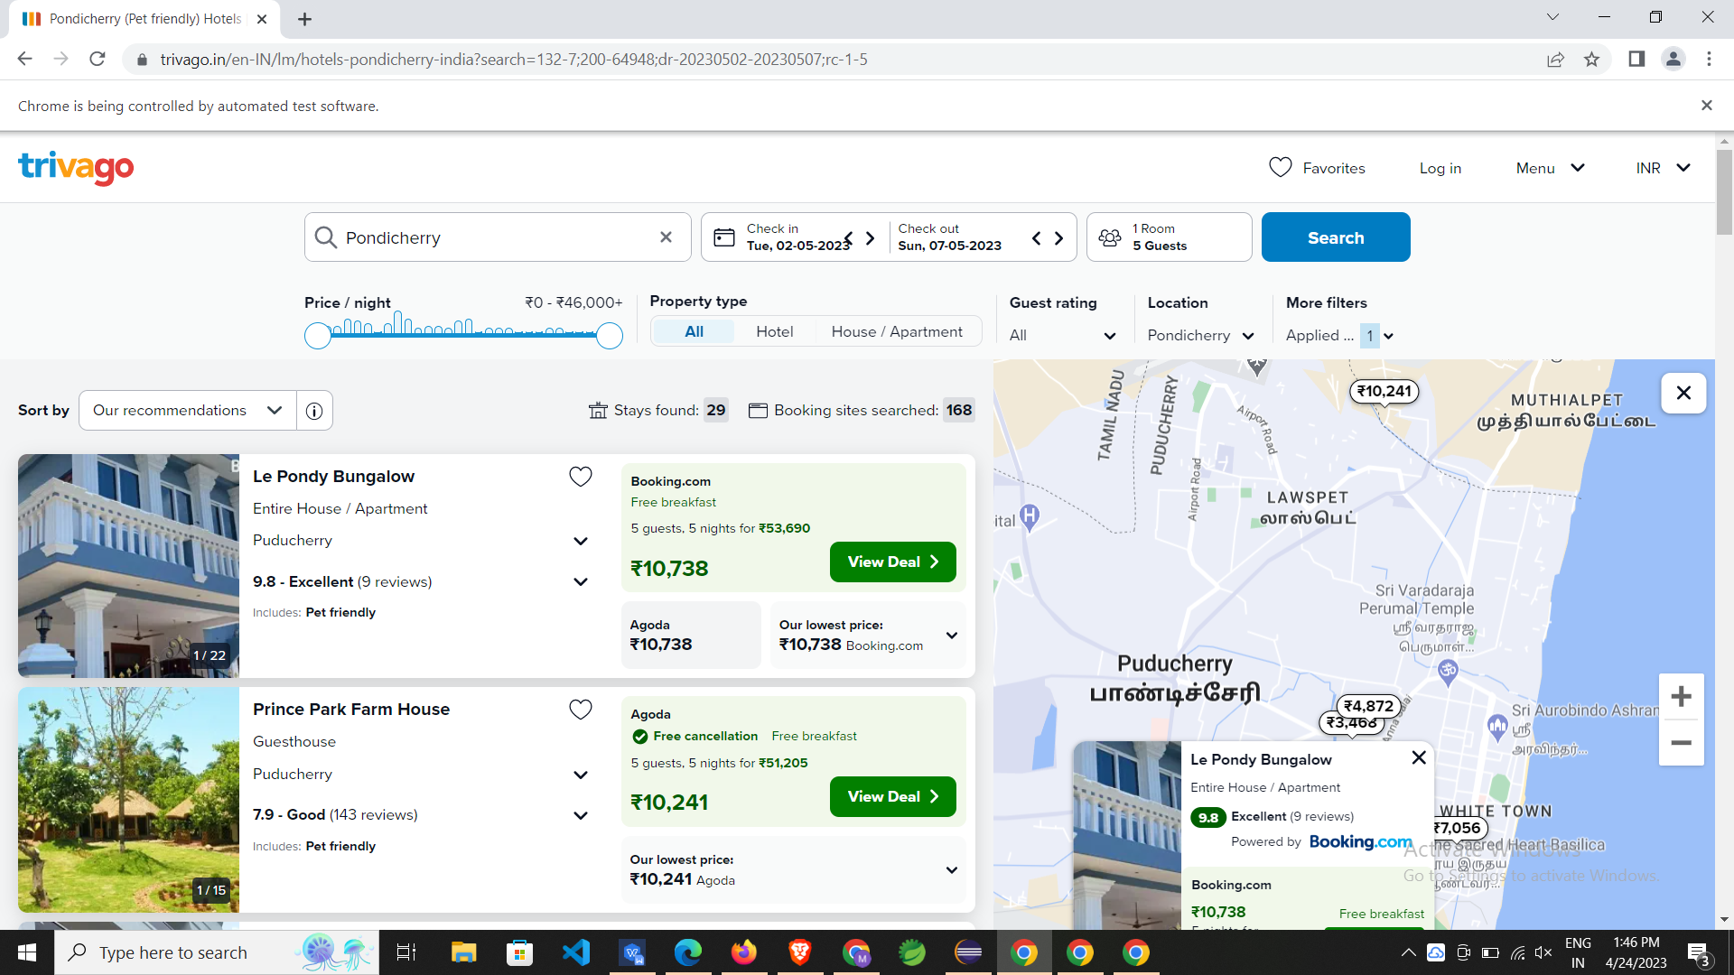

TASK-2

**package** cia2;

**import** org.openqa.selenium.By;

**import** org.openqa.selenium.Keys;

**import** org.openqa.selenium.WebDriver;

**import** org.openqa.selenium.WebElement;

**import** org.openqa.selenium.chrome.ChromeDriver;

**import** org.openqa.selenium.chrome.ChromeOptions;

**import** org.openqa.selenium.edge.EdgeDriver;

**import** org.testng.annotations.Test;

**import** io.github.bonigarcia.wdm.WebDriverManager;

**public** **class** ques2 {

@Test

**public** **void** f() **throws** InterruptedException {

WebDriverManager.*chromedriver*().setup();

WebDriver driver;

ChromeOptions co = **new** ChromeOptions();

co.addArguments("--remote-allow-origins=*");

driver=**new** ChromeDriver(co);

driver.get("https://www.trivago.in/");

driver.manage().window().maximize();

String originalTitle = "trivago.in - Compare hotel prices worldwide";

String title = driver.getTitle();

**if**(title.equals(originalTitle)) {

System.***out***.println(title);

System.***out***.println("Page title validated");

}

// driver.findElement(By.xpath("//*[@id=\"__next\"]/div[1]/div[1]/section/div[2]/div[2]/div/div[1]/button[1]")).click();

// Thread.sleep(3000);

WebElement go=driver.findElement(By.*id*("input-auto-complete"));

go.click();

Thread.*sleep*(2000);

// WebElement uname=driver.findElement(By.xpath("//*[@id=\"input-auto-complete\"]"));

// Thread.sleep(2000);

go.sendKeys("Bengaluru");

go.sendKeys(Keys.***ENTER***);

WebElement dt=driver.findElement(By.*xpath*("//*[@id=\"__next\"]/div[1]/div[1]/section/div[2]/div[3]/div/div[1]/fieldset/button[1]/span"));

dt.click();

Thread.*sleep*(2000);

driver.findElement(By.*xpath*("//*[@id=\"__next\"]/div[1]/div[1]/section/div[2]/div[3]/div/div[2]/div/div/div/div[2]/div/div[1]/div[2]/button[31]/time")).click();

Thread.*sleep*(2000);

driver.findElement(By.*xpath*("//*[@id=\"__next\"]/div[1]/div[1]/section/div[2]/div[3]/div/div[2]/div/div/div/div[2]/div/div[2]/div[2]/button[3]/time")).click();

Thread.*sleep*(2000);

driver.findElement(By.*xpath*("//*[@id=\"__next\"]/div[1]/div[1]/section/div[2]/div[3]/div/div[2]/div/div/div[1]/div/div[2]/div[2]")).click();

Thread.*sleep*(2000);

driver.findElement(By.*xpath*("//*[@id=\"__next\"]/div[1]/div[1]/section/div[2]/div[3]/div/button")).click();

Thread.*sleep*(40000);

driver.findElement(By.*xpath*("//*[@id=\"__next\"]/div[1]/main/div[2]/div[1]/div/div/div/div[5]/div/button/span")).click();

Thread.*sleep*(2000);

driver.findElement(By.*xpath*("//*[@id=\"sorting-selector\"]")).click();

Thread.*sleep*(2000);

driver.findElement(By.*xpath*("//*[@id=\"sorting-selector\"]/option[3]")).click();

Thread.*sleep*(2000);

System.***out***.println("Hotel name = Treebo Trend Saga Comforts");

Thread.*sleep*(2000);

System.***out***.println("Hotel price = 2071");

Thread.*sleep*(2000);

driver.findElement(By.*xpath*("//*[@id=\"sorting-selector\"]")).click();

Thread.*sleep*(2000);

driver.findElement(By.*xpath*("//*[@id=\"sorting-selector\"]/option[6]")).click();

Thread.*sleep*(2000);

System.***out***.println("Spot On 73621 Srinivasa Boarding And Lodging");

Thread.*sleep*(2000);

System.***out***.println(461);

Thread.*sleep*(2000);

System.***out***.println("Stays found: 593");

Thread.*sleep*(2000);

System.***out***.println("Booking sites searched: 168");

Thread.*sleep*(2000);

}

}

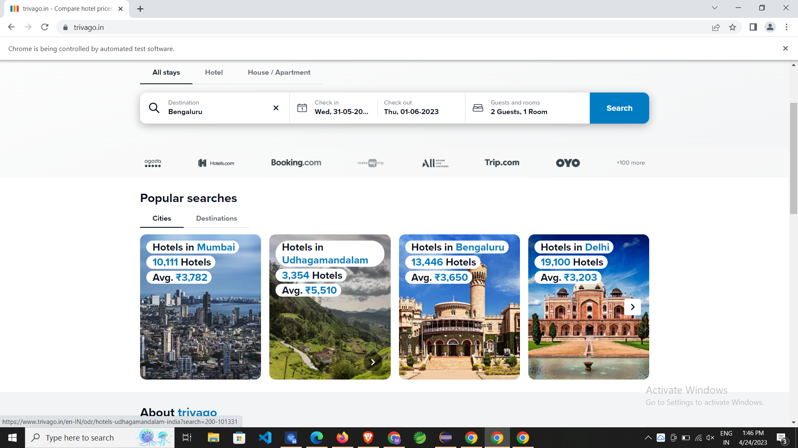

TASK-3

**package** cia2;

**import** java.util.List;

**import** org.openqa.selenium.By;

**import** org.openqa.selenium.WebDriver;

**import** org.openqa.selenium.WebElement;

**import** org.openqa.selenium.chrome.ChromeDriver;

**import** org.openqa.selenium.chrome.ChromeOptions;

**import** org.testng.annotations.Test;

**import** io.github.bonigarcia.wdm.WebDriverManager;

**public** **class** ques3 {

@Test

**public** **void** qn3() **throws** InterruptedException {

WebDriverManager.*chromedriver*().setup();

WebDriver driver;

ChromeOptions co = **new** ChromeOptions();

co.addArguments("--remote-allow-origins=*");

driver = **new** ChromeDriver(co);

driver.manage().window().maximize();

driver.navigate().to("https://www.trivago.in/en-IN/srl/cheap-hotels-pondicherry-india?search=200-64948;dr-20230511-20230512;so-4");

String title=driver.getTitle();

System.***out***.println(title);

**if**(title.equals("Pondicherry Hotels | Find & compare great deals on trivago"))

System.***out***.println("Title validated");

**else**

System.***out***.println("Title not validated");

Thread.*sleep*(32000);

List<WebElement> sele = driver.findElements(By.*xpath*("//*[@id=\"__next\"]/div[1]/main/div[5]/section"));

System.***out***.println(sele.size());

**int** i=0;

**for** (WebElement webElement : sele) {

**if**(i==5)

**break**;

String name = webElement.getText();

System.***out***.println(name);

i++;

}

}

}

